Project Journal

**25/01/19**

Trouble connecting Azure SQL database to Web App.

Error - Call to undefined function sqlsrv_connect()

Switched to Azure for MySQL

Connection Successful

Register Users Function – Pass

Passwords encrypted using md5

Login User – Pass

Created User Authentication -> Can’t access services unless logged on

Users can log out

**27/01/19**

Created Services Page

Populated Services Table with Data

Query Data from Services Table to Services Page

Created $_SESSION variable that displays user’s first name when logged in

**28/01/19**

Authenication Issue – Unique Email Validation

Errror - Trying to get property of non-object

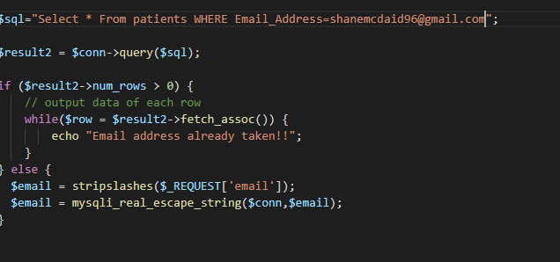

Corrected Issue

Fixed issue – passwords must match in order to register

Fixed Issue – passwords must be at least 8 character minimum and include at least one lowercase, uppercase and special character

**30/01/19**

Looked at Syncfunsion JavaScript APIs for appointment scheduling

<https://ej2.syncfusion.com/home/>

APIs won’t work on app as I am using PHP for my backend. However, I can create a scheduler with an Angular Frontend which I may look into more

<https://code.daypilot.org/tutorials/php>

**01/02/19**

Started layout design for booking page

Still need to figure out the double-booking situation.

Need to research more information on how I can create a date/time calendar that only includes free dates.

**04/02/19**

Finished layout design for booking page

Added a dropdown with a function that displays half hour intervals between 9am and 5pm.

Added a jquery daypicker function to booking page. Calender is set where you cannot select Saturday or Sunday and you can’t book before current date or more than two months in the future.

Booking Function working but still has issues such as double booking

**05/02/19**



Error – Getting ID of Service when booking an appointment.

Fixed Issue – Syntax Error for Service ID

Fixed Issue – retrieving Dentist ID from POST form.

Double booking still an issue.

**06/02/19**

Fixed Double Booking issue

**07/02/19**

Created view bookings page

Users can delete appointments

Issue with edit button – Bootstrap Modal (Can’t get App ID and datepicker displays behind)

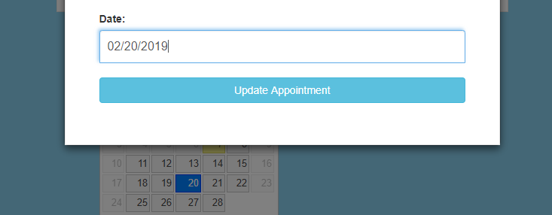



**11/02/19**

Downloaded csv files regarding dental datasets from data.gov.ie

Converted csv file into json

Imported Json file into mysql workbench

Result: Denture Repairs Table

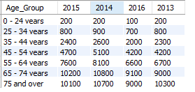

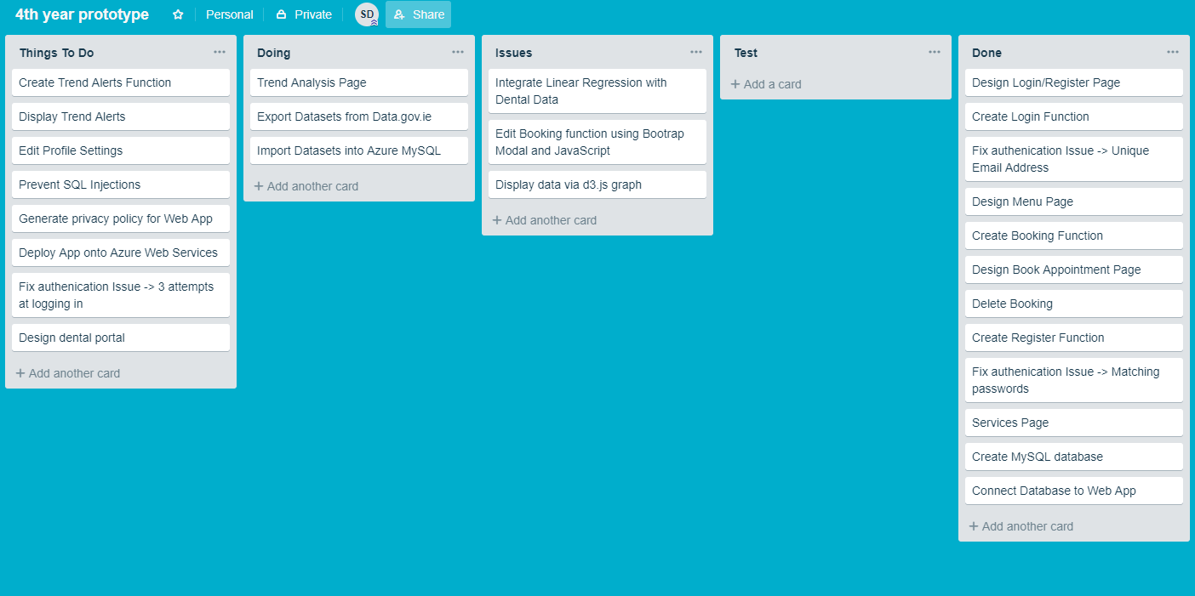

**13/02/19**

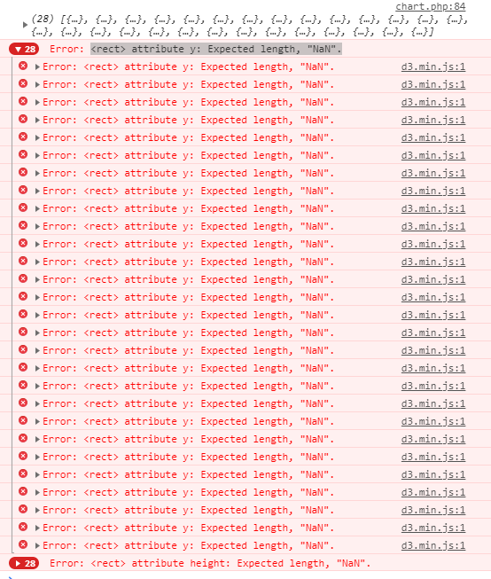

D3.js error – How to fix??

Dropped denture repairs table from trends database

Save json-stat file from <https://www.cso.ie/StatbankServices/StatbankServices.svc/jsonservice/responseinstance/DTA06>

Import json-stat into database – failed!!

Converted json-stat into csv file

Imported csv file into database – success

Via Javascript convert database dataset through json_encodes

**14/02/19**

Denture repairs

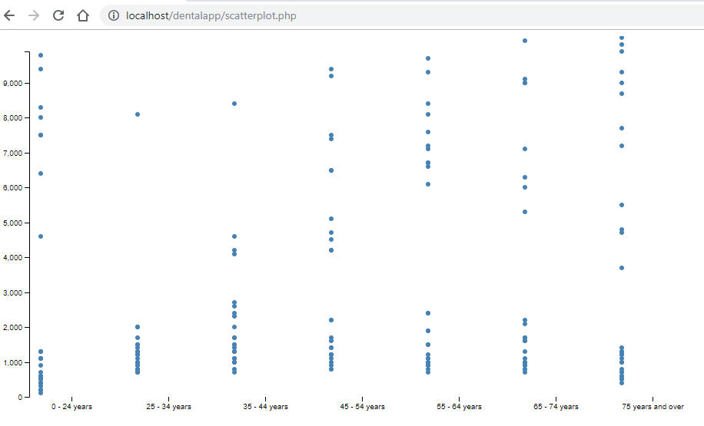

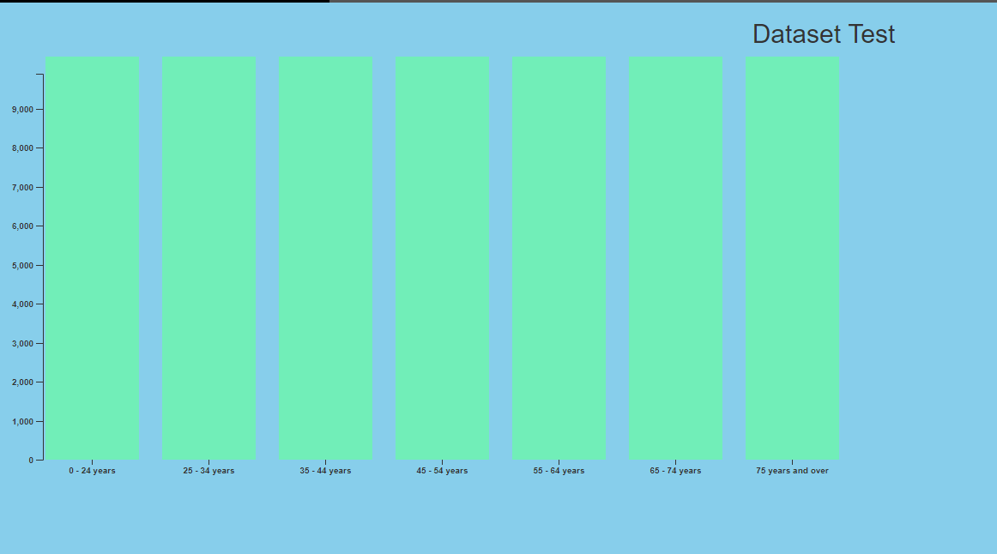

How to run linear regression with a numeric variable and a categorical variable?

Age Group (Categorical) & Value (Numeric)

**17/02/19**

Looked at Machine Learning Studio Azure – An Alternative to d3.js

Linear Regression test run

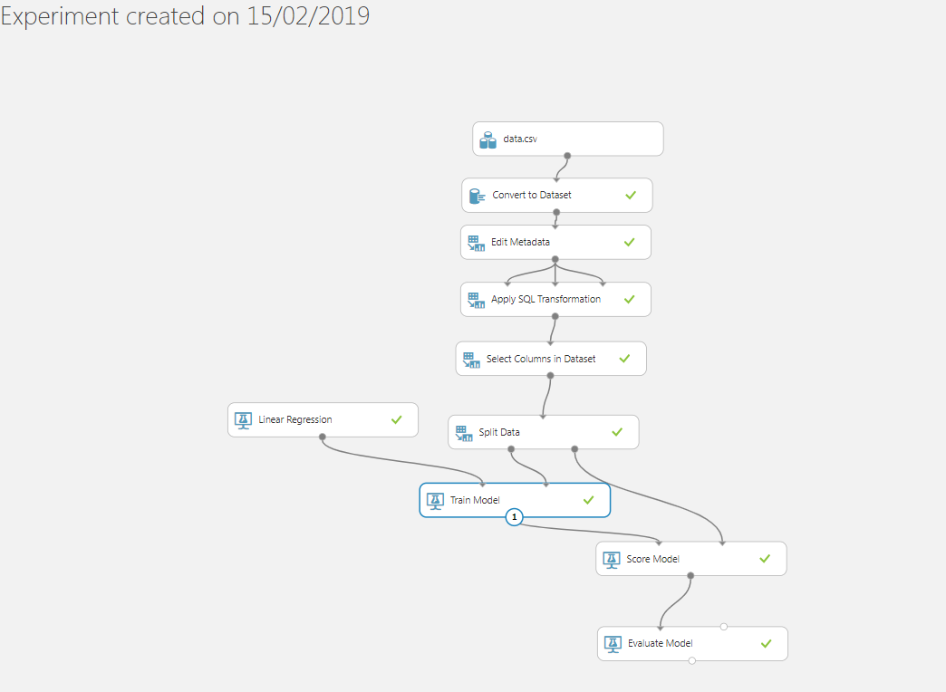

Design Layout for Trend Alert page

Page design as of 17th of February

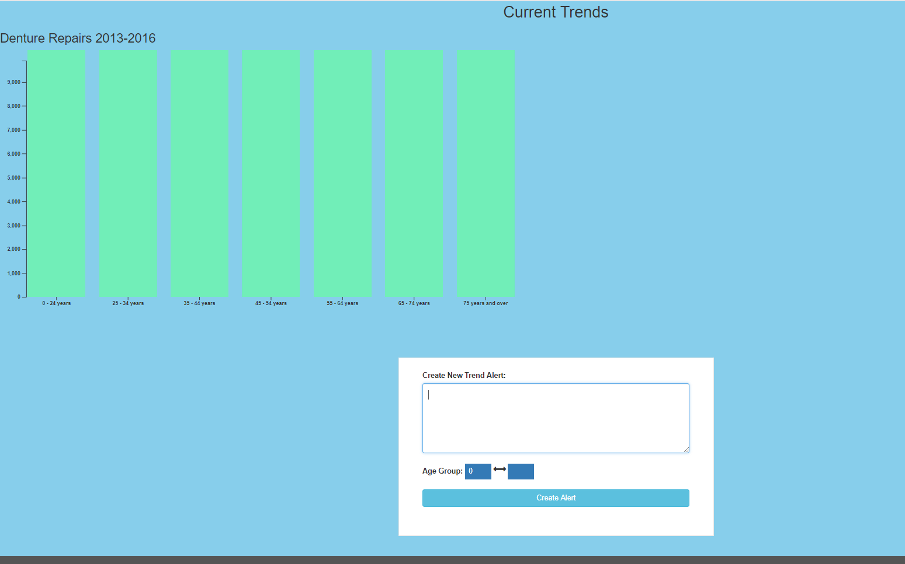

**19/02/19**

Trouble with Linear Regression formula.

**Do I need to change the X-axis value from a string to an int?**

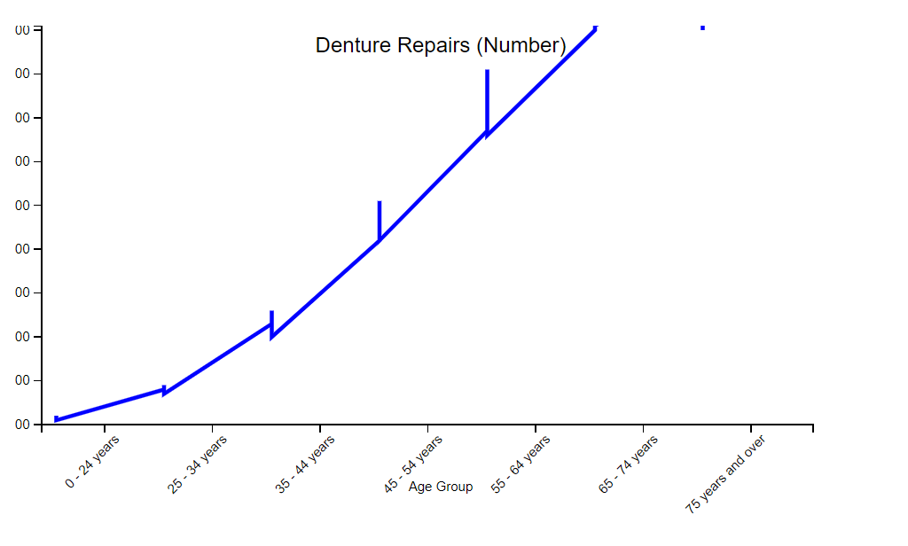

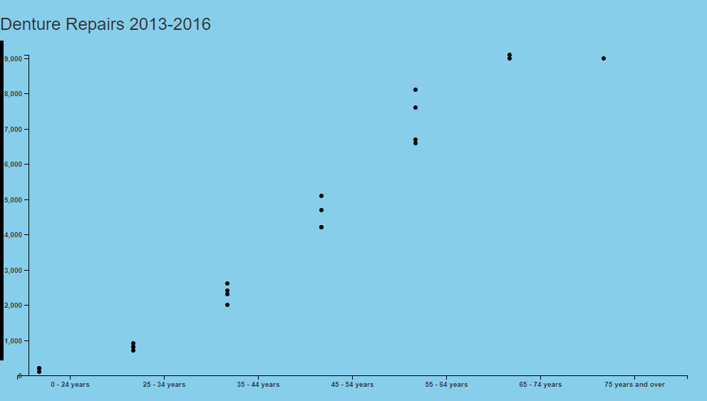

**21/02/19**

Fixed Linear Regression issue – the dataset wasn’t suitable to run formula.

Generate some dummy data to be accurate as the data in the dataset.

Week 5 Trello:

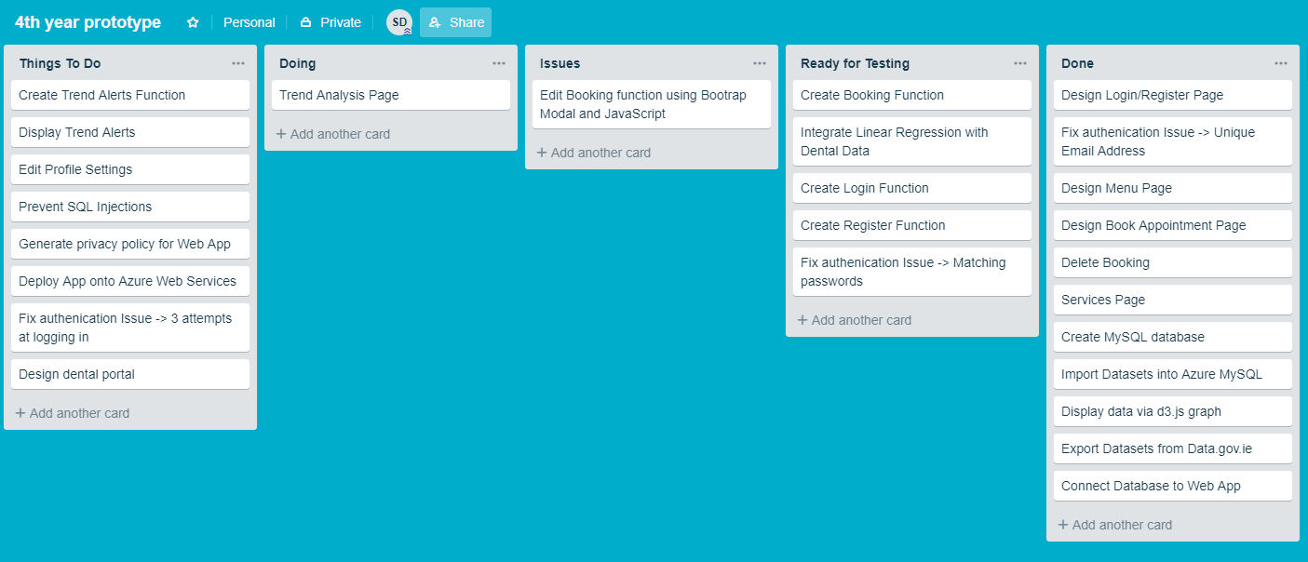

Linear Regression Demo:

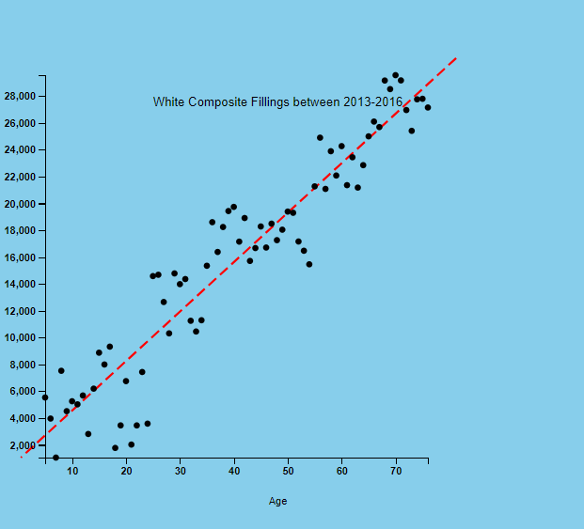

**25/02/19**

This week I will look at web scraping for dental prices

Maybe use chrome extension tools

I designed bootstrap modal to display trends on user home page

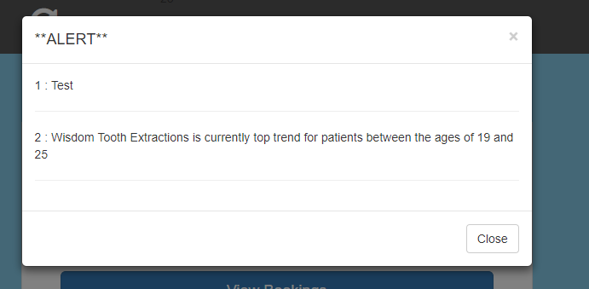

SQL Table for trend alerts

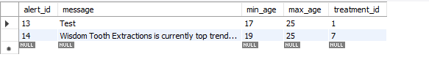

Week 6 Trello

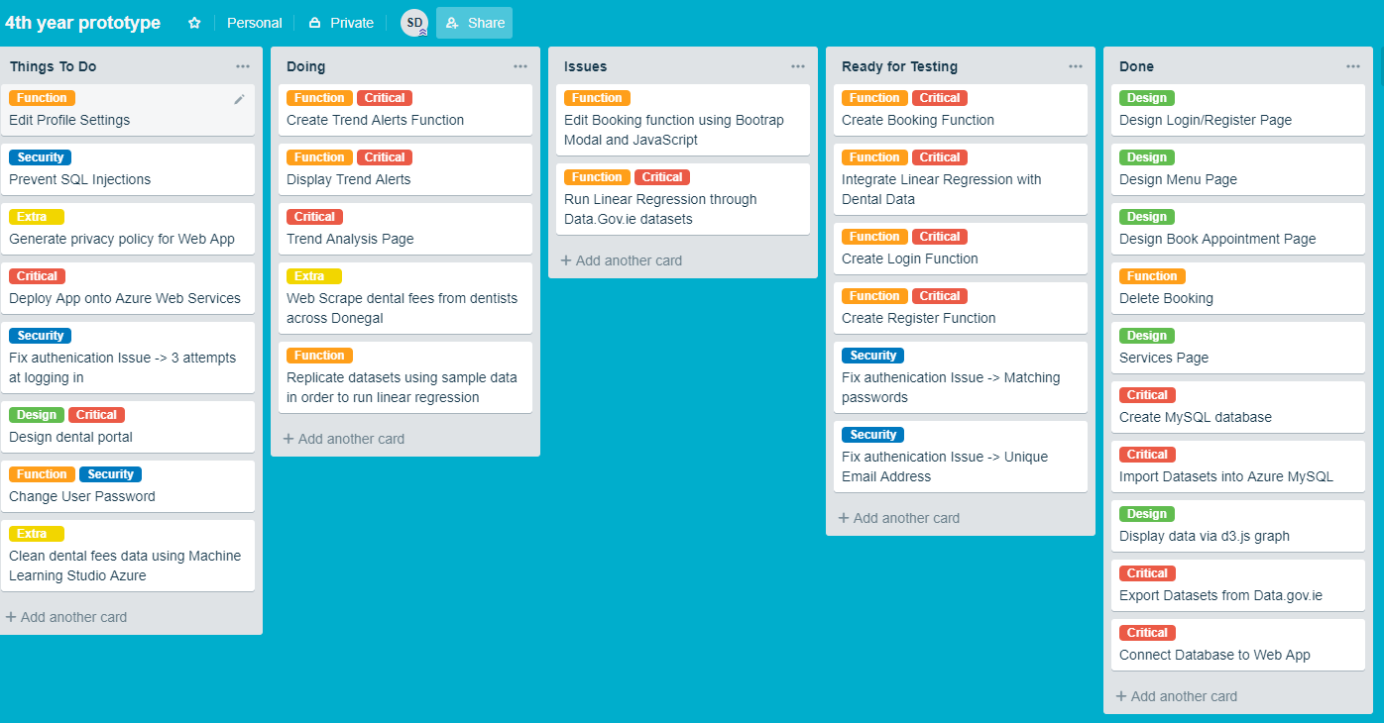

**26/02/19**

Added name bar underneath header to display user’s name using $_SESSION variables

Upgraded version of bootstrap form version 3.6 to 4.

The reason for this was to implement a toggle sidebar for settings on home page.

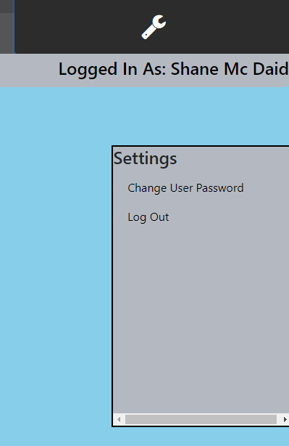

Still unclear about web scraping!!

**04/03/19**

Redoing Scheduler so that add,edit and delete works on a single page without reload.

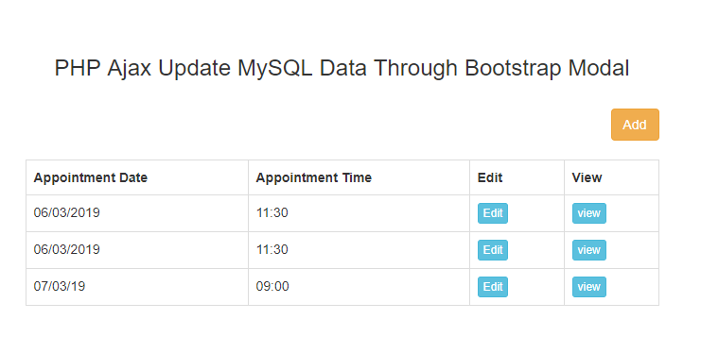

**Problem with datepicker?**

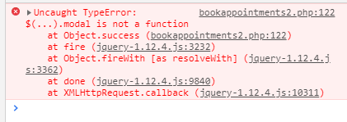

**05/03/19**

Fixed Issue with datepicker – too many jquery script tags

Completed Scheduler – all functionality works on single page.

Removed view bookings page – not needed

Will look at finishing the trend alert dashboard next!!

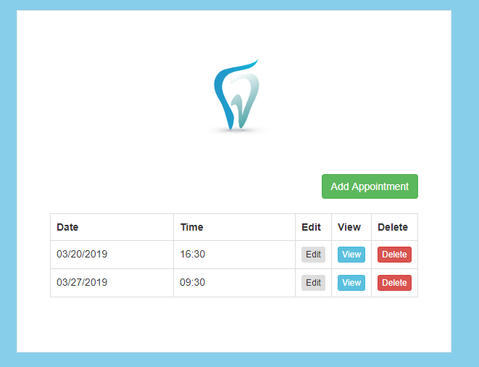

**06/03/19**

Discovered Issue regarding Scheduler

Can add appointment and edit

But can’t edit and then add, this overwrites the last appointment which was edited

Will use different template code - <https://www.itechempires.com/2016/03/php-mysql-crud-create-read-update-delete-operations-using-jquery/>

**10/03/19**

Fixed Issue with Scheduler.

Will finish CSS of it at the weekend

Will spend rest of week finishing Dashboard!!

**14/03/19**

Uploading new dummy data onto database

Reconnected graph to database

Created and added two more linear regression graphs

Fixed CSS so that the graphs are mobile responsive.

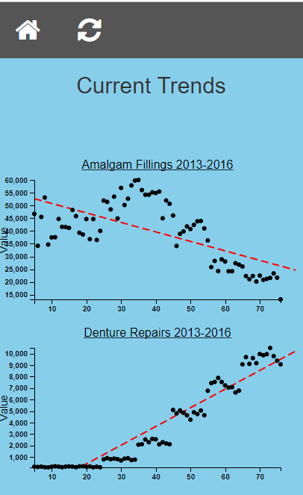

Week 8 Trello

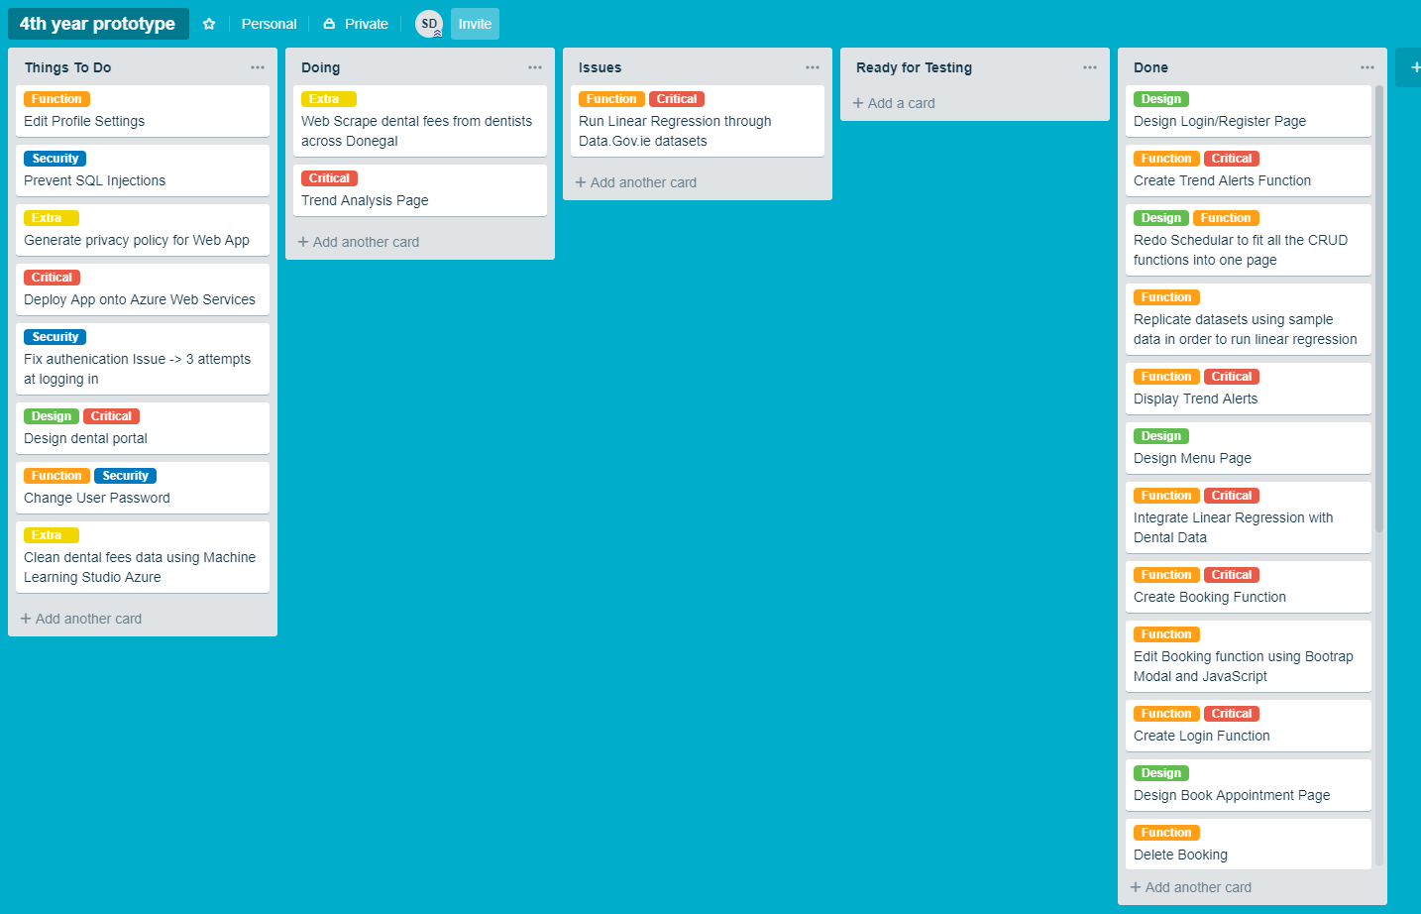

**16/03/19**

Finished reimplementing Scheduler. Fully done. Ready for Testing

Used a web scraping tool called grepsr – was able to scrape 3 donegal dental websites – station house, fox surgery and errigal dental. Majority of dentists in Donegal don’t show their prices nor even have a website – slight issue!!

Added 3 new columns to patient table and edited the register function to include them - Sex, Phone Number and PPS Number

Will clean data which I scraped tomorrow and display it with d3

**20/03/19**

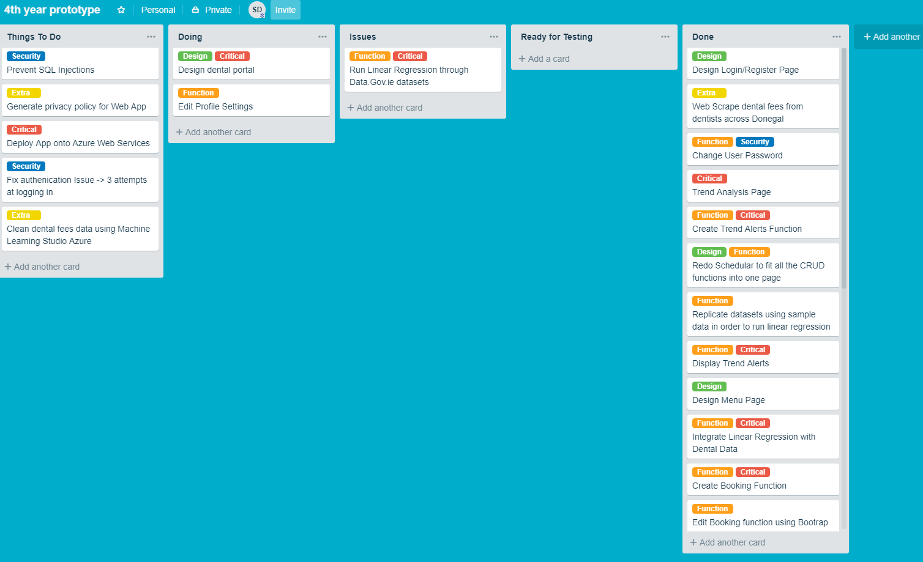Week 9 Trello

Working on Dentist Portal

Finished add, delete and update service function

Users can change passwords

Can create dentist accounts

Next – Dentist Login Screen and appointment function

**22/03/19**

Dentist Login Screen and appointment function – complete

When booking appointments, dentists search user by ID or Email

Generate a privacy policy so users must accept it when signing up

Next – Forget Password function using php mail()

**23/03/19**

Php mail() won’t work with Azure

Azure do not have a smtp server to send emails

Tried using a third-party server called SendGrid – Failed to deploy

Error - ResourcePurchaseValidationFailed

Will look at an alternative method to rest user password

**29/03/19**

Postponed email server search, to work on SQL Injection Prevention

Roughly 80% of SQL queries are now using prepared statements to block Injections.

To reset user password, user must contact dentist via telephone and answer security question.

Will look for third-party email server

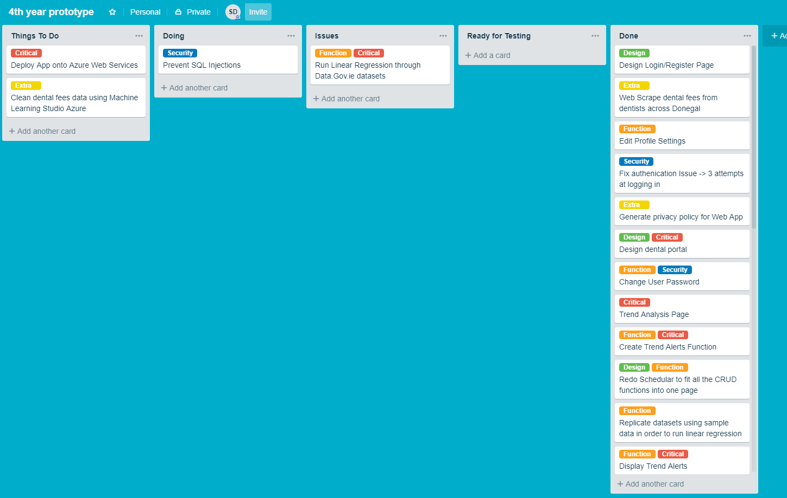 Week 10 Trello